MINI PROJECT

Name: Riza sajjad shaikh
Roll no : AI2094
Topic : Student management system

Code:
import tkinter as tk
from tkinter import ttk, messagebox
import sqlite3

# ================= DATABASE =================
db = sqlite3.connect("smart_students.db")
cur = db.cursor()

cur.execute("""
CREATE TABLE IF NOT EXISTS students (
id INTEGER PRIMARY KEY AUTOINCREMENT,
roll TEXT UNIQUE NOT NULL,
name TEXT NOT NULL,
course TEXT NOT NULL,
marks REAL NOT NULL,
attendance REAL NOT NULL
)
""")

# Add address column automatically to an old database
cur.execute("PRAGMA table_info(students)")
columns_in_db = [col[1] for col in cur.fetchall()]

if "address" not in columns_in_db:
cur.execute(
"ALTER TABLE students ADD COLUMN address TEXT NOT NULL DEFAULT ''"
)

db.commit()

# ================= COLORS =================
BG = "#F5F3FF"
PURPLE = "#6D28D9"
DARK = "#24124D"
WHITE = "#FFFFFF"
TEXT = "#292044"
MUTED = "#807795"
GREEN = "#059669"
ORANGE = "#EA580C"
RED = "#DC2626"

COURSES = [
"CSE",
"AI & ML",
"Civil Engineering",
"Mechanical Engineering",
"Electronics Engineering",
"Electrical Engineering"
]

# ================= WINDOW =================
root = tk.Tk()
root.title("Smart Student | Management System")
root.geometry("1200x760")
root.minsize(1000, 650)
root.configure(bg=BG)

style = ttk.Style()
style.theme_use("clam")

style.configure(
"Treeview",
background=WHITE,
foreground=TEXT,
rowheight=30,
fieldbackground=WHITE,
font=("Arial", 9)
)

style.configure(
"Treeview.Heading",
background=DARK,
foreground=WHITE,
padding=8,
font=("Arial", 9, "bold")
)

style.map(
"Treeview",
background=[("selected", "#DDD6FE")]
)

# ================= VARIABLES =================
roll_var = tk.StringVar()
name_var = tk.StringVar()
course_var = tk.StringVar(value=COURSES[0])
address_var = tk.StringVar()
marks_var = tk.StringVar()
attendance_var = tk.StringVar(value="100")
selected_id = tk.StringVar()
search_var = tk.StringVar()

# ================= GRADE FUNCTION =================
def grade(marks):
if marks >= 90:
return "A+"
elif marks >= 80:
return "A"
elif marks >= 70:
return "B"
elif marks >= 60:
return "C"
elif marks >= 40:
return "D"
return "Fail"

# ================= CLEAR FORM =================
def clear_form():
roll_var.set("")
name_var.set("")
course_var.set(COURSES[0])
address_var.set("")
marks_var.set("")
attendance_var.set("100")
selected_id.set("")

if table.selection():
table.selection_remove(table.selection())

# ================= LOAD SELECTED STUDENT =================
def load_form(event=None):
chosen = table.selection()

if not chosen:
return

row = table.item(chosen[0], "values")

selected_id.set(str(row[0]))
roll_var.set(row[1])
name_var.set(row[2])
course_var.set(row[3])
address_var.set(row[4])
marks_var.set(row[5])
attendance_var.set(row[6].replace("%", ""))

# ================= REFRESH TABLE =================
def refresh():
for item in table.get_children():
table.delete(item)

keyword = search_var.get().strip()

cur.execute("""
SELECT id, roll, name, course, address, marks, attendance
FROM students
WHERE roll LIKE ?
OR name LIKE ?
OR course LIKE ?
OR address LIKE ?
ORDER BY id DESC
""", (
f"%{keyword}%",
f"%{keyword}%",
f"%{keyword}%",
f"%{keyword}%"
))

records = cur.fetchall()

for row in records:
table.insert("", "end", values=(
row[0],
row[1],
row[2],
row[3],
row[4],
f"{row[5]:g}",
f"{row[6]:g}%",
grade(row[5])
))

cur.execute("""
SELECT COUNT(*), AVG(marks), COUNT(DISTINCT course)
FROM students
""")

total, average, courses = cur.fetchone()

total_value.config(text=str(total))
course_value.config(text=str(courses))

average_value.config(
text=f"{average:.1f}" if average is not None else "0.0"
)

result_label.config(
text=f"{len(records)} student(s) displayed"
)

# ================= GET FORM DATA =================
def get_data():
roll = roll_var.get().strip()
name = name_var.get().strip()
course = course_var.get().strip()
address = address_var.get().strip()

if not roll or not name or not course or not address:
messagebox.showwarning(
"Missing Details",
"Please enter Roll Number, Name, Course and Address."
)
return None

if course not in COURSES:
messagebox.showerror(
"Invalid Course",
"Please select a valid course."
)
return None

try:
marks = float(marks_var.get())
attendance = float(attendance_var.get())

if not 0 <= marks <= 100:
raise ValueError("Marks must be between 0 and 100.")

if not 0 <= attendance <= 100:
raise ValueError(
"Attendance must be between 0 and 100."
)

except ValueError as error:
messagebox.showerror(
"Invalid Input",
str(error) or "Please enter valid numeric values."
)
return None

return roll, name, course, address, marks, attendance

# ================= ADD STUDENT =================
def add_student():
data = get_data()

if data is None:
return

try:
cur.execute("""
INSERT INTO students
(roll, name, course, address, marks, attendance)
VALUES (?, ?, ?, ?, ?, ?)
""", data)

db.commit()
refresh()
clear_form()

messagebox.showinfo(
"Success",
"Student added successfully!"
)

except sqlite3.IntegrityError:
messagebox.showerror(
"Duplicate Roll Number",
"This Roll Number already exists."
)

# ================= UPDATE STUDENT =================
def update_student():
if not selected_id.get():
messagebox.showwarning(
"Select Student",
"Select a student from the table first."
)
return

data = get_data()

if data is None:
return

try:
cur.execute("""
UPDATE students
SET roll=?, name=?, course=?, address=?,
marks=?, attendance=?
WHERE id=?
""", (*data, selected_id.get()))

db.commit()
refresh()
clear_form()

messagebox.showinfo(
"Updated",
"Student record updated successfully!"
)

except sqlite3.IntegrityError:
messagebox.showerror(
"Duplicate Roll Number",
"Another student already uses this Roll Number."
)

# ================= DELETE STUDENT =================
def delete_student():
if not selected_id.get():
messagebox.showwarning(
"Select Student",
"Select a student from the table first."
)
return

confirm = messagebox.askyesno(
"Confirm Delete",
"Are you sure you want to delete this student?"
)

if confirm:
cur.execute(
"DELETE FROM students WHERE id=?",
(selected_id.get(),)
)

db.commit()
refresh()
clear_form()

messagebox.showinfo(
"Deleted",
"Student record deleted successfully."
)

# ================= SHOW ALL STUDENTS =================
def show_all():
search_var.set("")
refresh()

# ================= BUTTON DESIGN =================
def make_button(parent, text, color, command):
return tk.Button(
parent,
text=text,
command=command,
bg=color,
fg=WHITE,
activebackground=color,
activeforeground=WHITE,
relief="flat",
cursor="hand2",
font=("Arial", 9, "bold"),
padx=10,
pady=7
)

# ================= REPORT WINDOW =================
def open_reports():
report_win = tk.Toplevel(root)
report_win.title("Student Reports")
report_win.geometry("1100x620")
report_win.minsize(850, 500)
report_win.configure(bg=BG)

tk.Label(
report_win,
text="Student Reports",
bg=BG,
fg=TEXT,
font=("Arial", 22, "bold")
).pack(anchor="w", padx=20, pady=(18, 3))

tk.Label(
report_win,
text="View student records by address, branch or marks.",
bg=BG,
fg=MUTED,
font=("Arial", 10)
).pack(anchor="w", padx=20, pady=(0, 14))

# Report controls
controls = tk.Frame(
report_win,
bg=WHITE,
padx=12,
pady=12
)
controls.pack(fill="x", padx=20, pady=(0, 12))

tk.Label(
controls,
text="Report Type:",
bg=WHITE,
fg=TEXT,
font=("Arial", 10, "bold")
).pack(side="left", padx=(0, 8))

report_type = tk.StringVar(value="All Students")

report_combo = ttk.Combobox(
controls,
textvariable=report_type,
values=[
"All Students",
"Address-wise",
"Branch-wise",
"Marks-wise"
],
state="readonly",
width=18
)
report_combo.pack(side="left", padx=(0, 12))

filter_var = tk.StringVar()

filter_entry = tk.Entry(
controls,
textvariable=filter_var,
font=("Arial", 10),
relief="solid",
bd=1,
width=23
)
filter_entry.pack(side="left", ipady=5, padx=(0, 8))

hint_label = tk.Label(
controls,
text="Optional filter",
bg=WHITE,
fg=MUTED,
font=("Arial", 9)
)
hint_label.pack(side="left", padx=(0, 10))

# Report table
report_columns = (
"ID", "Roll No", "Name", "Course",
"Address", "Marks", "Attendance", "Grade"
)

report_table = ttk.Treeview(
report_win,
columns=report_columns,
show="headings",
selectmode="browse"
)

widths = [40, 75, 130, 145, 220, 65, 90, 65]

for col, width in zip(report_columns, widths):
report_table.heading(col, text=col)
report_table.column(
col,
width=width,
minwidth=55,
anchor="center"
)

report_scroll_y = ttk.Scrollbar(
report_win,
orient="vertical",
command=report_table.yview
)

report_scroll_x = ttk.Scrollbar(
report_win,
orient="horizontal",
command=report_table.xview
)

report_table.configure(
yscrollcommand=report_scroll_y.set,
xscrollcommand=report_scroll_x.set
)

report_scroll_y.pack(
side="right",
fill="y",
padx=(0, 20)
)

report_table.pack(
fill="both",
expand=True,
padx=(20, 0)
)

report_scroll_x.pack(
fill="x",
padx=20
)

report_status = tk.Label(
report_win,
text="",
bg=BG,
fg=MUTED,
font=("Arial", 9)
)
report_status.pack(anchor="w", padx=20, pady=10)

# Change filter instructions
def update_hint(event=None):
kind = report_type.get()

if kind == "Address-wise":
hint_label.config(text="Enter address (optional)")
elif kind == "Branch-wise":
hint_label.config(text="Enter branch (optional)")
elif kind == "Marks-wise":
hint_label.config(text="Minimum marks, e.g. 75")
else:
hint_label.config(text="Name, roll or course (optional)")

# Generate selected report
def generate_report():
for item in report_table.get_children():
report_table.delete(item)

kind = report_type.get()
keyword = filter_var.get().strip()

sql = """
SELECT id, roll, name, course, address, marks, attendance
FROM students
"""

params = []
order = " ORDER BY id DESC"

if kind == "Address-wise":
if keyword:
sql += " WHERE address LIKE ?"
params.append(f"%{keyword}%")

order = """
ORDER BY address COLLATE NOCASE,
name COLLATE NOCASE
"""

elif kind == "Branch-wise":
if keyword:
sql += " WHERE course LIKE ?"
params.append(f"%{keyword}%")

order = """
ORDER BY course COLLATE NOCASE,
name COLLATE NOCASE
"""

elif kind == "Marks-wise":
if keyword:
try:
minimum_marks = float(keyword)

if not 0 <= minimum_marks <= 100:
raise ValueError

except ValueError:
messagebox.showerror(
"Invalid Marks",
"Enter marks between 0 and 100, e.g. 75."
)
return

sql += " WHERE marks >= ?"
params.append(minimum_marks)

order = " ORDER BY marks DESC, name COLLATE NOCASE"

else:
if keyword:
sql += """
WHERE roll LIKE ?
OR name LIKE ?
OR course LIKE ?
OR address LIKE ?
"""
params.extend([f"%{keyword}%"] * 4)

cur.execute(sql + order, params)
records = cur.fetchall()

for row in records:
report_table.insert("", "end", values=(
row[0],
row[1],
row[2],
row[3],
row[4],
f"{row[5]:g}",
f"{row[6]:g}%",
grade(row[5])
))

if kind == "Marks-wise" and keyword:
report_status.config(
text=f"{len(records)} student(s) with marks >= {keyword}"
)
elif kind == "Address-wise":
report_status.config(
text=f"{len(records)} student(s), sorted by address"
)
elif kind == "Branch-wise":
report_status.config(
text=f"{len(records)} student(s), sorted by branch"
)
else:
report_status.config(
text=f"{len(records)} student(s) in this report"
)

make_button(
controls,
"Generate Report",
PURPLE,
generate_report
).pack(side="left", padx=4)

def reset_report():
filter_var.set("")
report_type.set("All Students")
update_hint()
generate_report()

make_button(
controls,
"Show All",
"#64748B",
reset_report
).pack(side="left", padx=4)

report_combo.bind("<<ComboboxSelected>>", update_hint)
filter_entry.bind(
"<Return>",
lambda event: generate_report()
)

update_hint()
generate_report()

# ================= SIDEBAR =================
sidebar = tk.Frame(root, bg=DARK, width=210)
sidebar.pack(side="left", fill="y")
sidebar.pack_propagate(False)

tk.Label(
sidebar,
text="✦ SMART STUDENT",
bg=DARK,
fg=WHITE,
font=("Arial", 17, "bold")
).pack(pady=(32, 5))

tk.Label(
sidebar,
text="MANAGEMENT PORTAL",
bg=DARK,
fg="#C4B5FD",
font=("Arial", 9, "bold")
).pack(pady=(0, 36))

tk.Label(
sidebar,
text="▦ Dashboard",
bg=PURPLE,
fg=WHITE,
font=("Arial", 12, "bold"),
anchor="w",
padx=18,
pady=13
).pack(fill="x", padx=12)

tk.Label(
sidebar,
text="♙ Students",
bg=DARK,
fg="#DDD6FE",
font=("Arial", 12),
anchor="w",
padx=18,
pady=13
).pack(fill="x", padx=12)

reports_nav = tk.Label(
sidebar,
text="▤ Reports",
bg=DARK,
fg="#DDD6FE",
font=("Arial", 12),
anchor="w",
padx=18,
pady=13,
cursor="hand2"
)
reports_nav.pack(fill="x", padx=12)

reports_nav.bind(
"<Button-1>",
lambda event: open_reports()
)

reports_nav.bind(
"<Enter>",
lambda event: reports_nav.config(bg=PURPLE, fg=WHITE)
)

reports_nav.bind(
"<Leave>",
lambda event: reports_nav.config(bg=DARK, fg="#DDD6FE")
)

tk.Label(
sidebar,
text="LEARN • TRACK • GROW\n\n"
"Simple student records,\nall in one place.",
bg=DARK,
fg="#A78BFA",
font=("Arial", 10),
justify="left"
).pack(side="bottom", anchor="w", padx=20, pady=25)

# ================= MAIN AREA =================
main = tk.Frame(root, bg=BG)
main.pack(
side="left",
fill="both",
expand=True,
padx=20,
pady=18
)

header = tk.Frame(main, bg=BG)
header.pack(fill="x")

tk.Label(
header,
text="Dashboard Overview",
bg=BG,
fg=TEXT,
font=("Arial", 23, "bold")
).pack(side="left")

tk.Label(
header,
text="Welcome, Admin",
bg=BG,
fg=MUTED,
font=("Arial", 10)
).pack(side="right", pady=10)

tk.Label(
main,
text="Your students. Your progress. One smart dashboard.",
bg=BG,
fg=MUTED,
font=("Arial", 10)
).pack(anchor="w", pady=(4, 17))

# ================= STATISTICS CARDS =================
stats = tk.Frame(main, bg=BG)
stats.pack(fill="x", pady=(0, 17))

for i in range(3):
stats.columnconfigure(i, weight=1)

def make_stat(col, title, color, initial):
card = tk.Frame(
stats,
bg=WHITE,
padx=15,
pady=14,
highlightbackground="#E9E2F8",
highlightthickness=1
)

card.grid(
row=0,
column=col,
sticky="ew",
padx=(0 if col == 0 else 7, 0)
)

tk.Label(
card,
text=title,
bg=WHITE,
fg=MUTED,
font=("Arial", 10, "bold")
).pack(anchor="w")

value = tk.Label(
card,
text=initial,
bg=WHITE,
fg=color,
font=("Arial", 24, "bold")
)

value.pack(anchor="w", pady=(5, 0))
return value

total_value = make_stat(0, "TOTAL STUDENTS", PURPLE, "0")
course_value = make_stat(1, "ACTIVE COURSES", GREEN, "0")
average_value = make_stat(2, "AVERAGE MARKS", ORANGE, "0.0")

# ================= STUDENT FORM =================
form = tk.Frame(
main,
bg=WHITE,
padx=14,
pady=10,
highlightbackground="#E9E2F8",
highlightthickness=1
)
form.pack(fill="x", pady=(0, 14))

tk.Label(
form,
text="✚ Student Details",
bg=WHITE,
fg=TEXT,
font=("Arial", 14, "bold")
).grid(
row=0,
column=0,
columnspan=4,
sticky="w",
pady=(0, 7)
)

for i in range(4):
form.columnconfigure(i, weight=1)

def add_field(title, variable, row, col, values=None):
tk.Label(
form,
text=title,
bg=WHITE,
fg=MUTED,
font=("Arial", 9, "bold")
).grid(
row=row,
column=col,
sticky="w",
padx=5,
pady=(2, 3)
)

if values:
widget = ttk.Combobox(
form,
textvariable=variable,
values=values,
state="readonly",
font=("Arial", 10)
)
else:
widget = tk.Entry(
form,
textvariable=variable,
font=("Arial", 10),
relief="solid",
bd=1
)

widget.grid(
row=row + 1,
column=col,
sticky="ew",
padx=5,
pady=(0, 6),
ipady=4
)

return widget

add_field("Roll Number *", roll_var, 1, 0)
add_field("Student Name *", name_var, 1, 1)
add_field("Course / Branch *", course_var, 1, 2, COURSES)
add_field("Marks (0-100) *", marks_var, 1, 3)
add_field("Address *", address_var, 3, 0)
add_field("Attendance % *", attendance_var, 3, 1)

buttons = tk.Frame(form, bg=WHITE)
buttons.grid(
row=4,
column=2,
columnspan=2,
sticky="e",
pady=3
)

make_button(buttons, "+ Add", PURPLE, add_student).pack(
side="left", padx=3
)

make_button(buttons, "Update", GREEN, update_student).pack(
side="left", padx=3
)

make_button(buttons, "Delete", RED, delete_student).pack(
side="left", padx=3
)

make_button(buttons, "Clear", "#64748B", clear_form).pack(
side="left", padx=3
)

# ================= STUDENT TABLE =================
records_box = tk.Frame(
main,
bg=WHITE,
padx=10,
pady=10,
highlightbackground="#E9E2F8",
highlightthickness=1
)
records_box.pack(fill="both", expand=True)

bar = tk.Frame(records_box, bg=WHITE)
bar.pack(fill="x", pady=(0, 8))

tk.Label(
bar,
text="Student Directory",
bg=WHITE,
fg=TEXT,
font=("Arial", 14, "bold")
).pack(side="left")

search_entry = tk.Entry(
bar,
textvariable=search_var,
font=("Arial", 10),
relief="solid",
bd=1,
width=18
)
search_entry.pack(side="right", padx=(5, 0), ipady=4)

make_button(bar, "Search", PURPLE, refresh).pack(
side="right", padx=4
)

make_button(bar, "Show All", "#64748B", show_all).pack(
side="right", padx=4
)

make_button(bar, "Reports", GREEN, open_reports).pack(
side="right", padx=4
)

columns = (
"ID", "Roll No", "Name", "Course",
"Address", "Marks", "Attendance", "Grade"
)

table = ttk.Treeview(
records_box,
columns=columns,
show="headings",
selectmode="browse"
)

widths = [35, 70, 115, 125, 170, 55, 80, 55]

for col, width in zip(columns, widths):
table.heading(col, text=col)
table.column(
col,
width=width,
minwidth=45,
anchor="center"
)

scroll = ttk.Scrollbar(
records_box,
orient="vertical",
command=table.yview
)

scroll_x = ttk.Scrollbar(
records_box,
orient="horizontal",
command=table.xview
)

table.configure(
yscrollcommand=scroll.set,
xscrollcommand=scroll_x.set
)

scroll.pack(side="right", fill="y")
table.pack(fill="both", expand=True)
scroll_x.pack(fill="x")

table.bind("<<TreeviewSelect>>", load_form)

result_label = tk.Label(
records_box,
text="0 student(s) displayed",
bg=WHITE,
fg=MUTED,
font=("Arial", 9)
)
result_label.pack(anchor="w", pady=(5, 0))

# ================= START APPLICATION =================
refresh()
root.mainloop()
db.close()

Output:
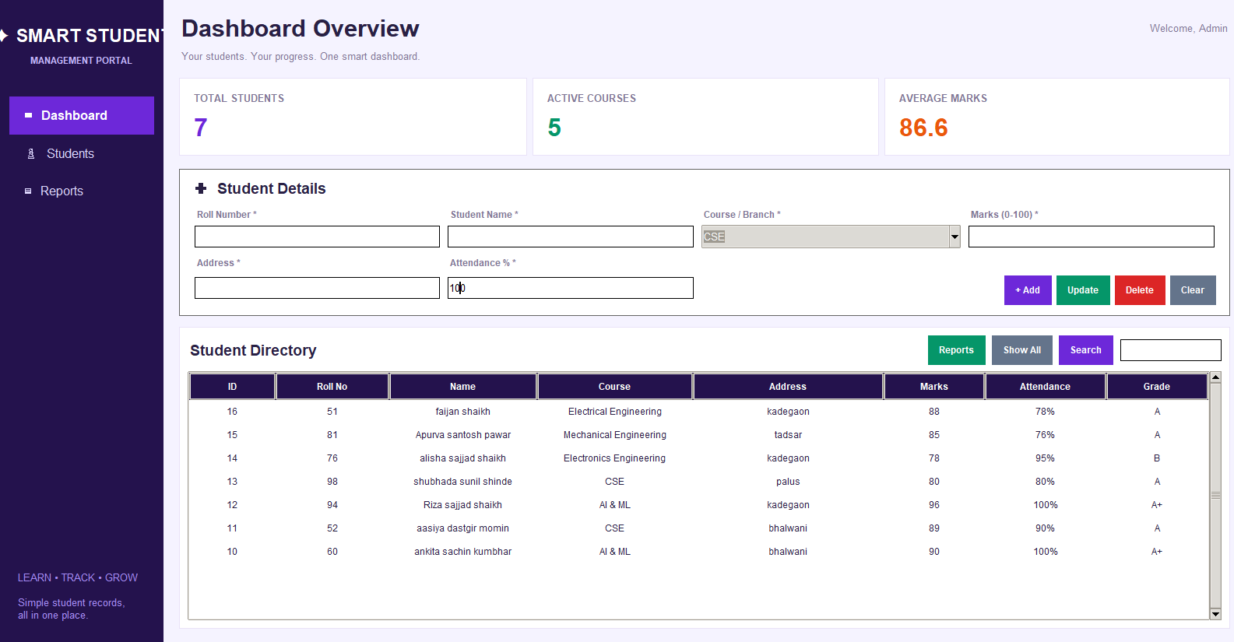

All Student Report:

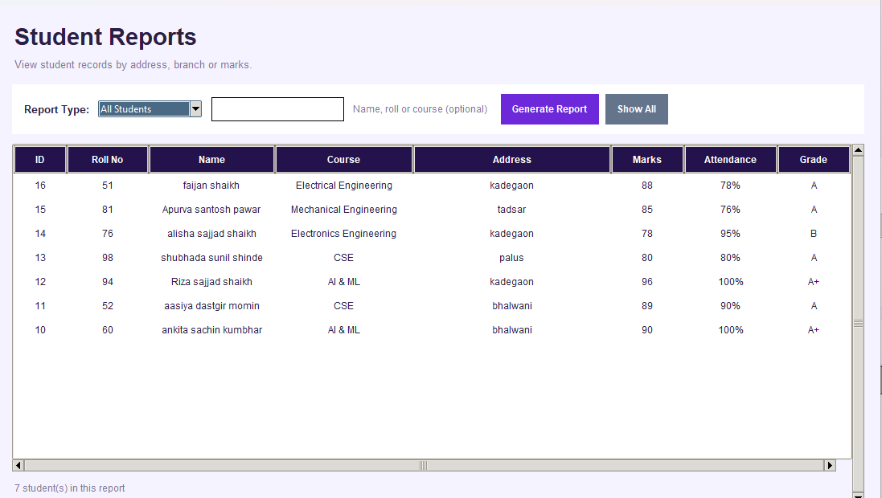

Address - wise Report:
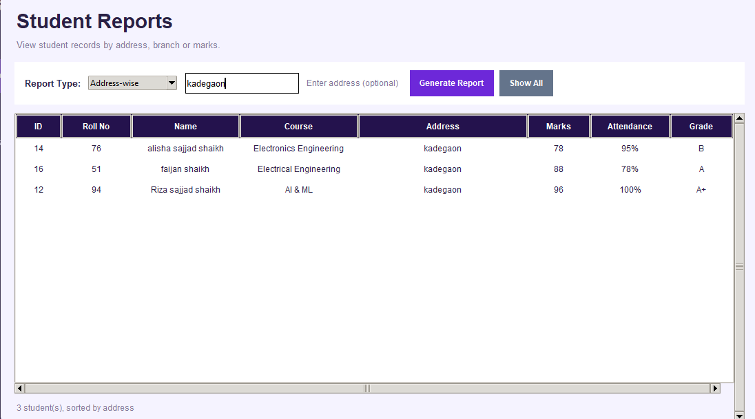

Mark -wise Report :

